PHYSICS 2, CHAPTER 1
ADDITIONAL PROBLEMS

1. In a car lift used in a service station, compressed air exerts a force on a small piston that has a circular cross section and a radius of 5.00 cm. This pressure is transmitted by a liquid to a piston that has a radius of 15.0 cm. What force must the compressed air exert to lift a car weighing 13300 N? What air pressure produces this force?

2. A slab has a thickness of 10.0 cm and a density of 300 kg/m³. When a 75.0-kg swimmer is resting on it, the slab floats in fresh water with its top at the same level as the water’s surface. Find the area of the slab.

3. A piece of aluminum with mass 1.00 kg and density 2 700 kg/m³ is suspended from a string and then completely immersed in a container of water Calculate the tension in the string
(a) before and
(b) after the metal is immersed.

4. A cube of wood having a side dimension of 20.0 cm and a density of 650 kg/m³ floats on water.
(a) What is the distance from the horizontal top surface of the cube to the water level?
(b) How much lead weight must be placed on top of the cube so that its top is just level with the water?

5. A large storage tank, open at the top and filled with water, develops a small hole in its side at a point 16.0 m below the water level. If the rate of flow from the leak is 2.50 × 10⁻³ m³/min, determine
(a) the speed at which the water leaves the hole and
(b) the diameter of the hole.

6. Water flows through a fire hose of diameter 6.35 cm at a rate of 0.012 0 m³/s. The fire hose ends in a nozzle with an inner diameter of 2.20 cm. What is the speed at which the water exits the nozzle?

7. An airplane has a mass of 1.60 × 10⁴ kg, and each wing has an area of 40.0 m². During level flight, the pressure on the lower wing surface is 7.00 × 10⁴ Pa. Determine the pressure on the upper wing surface.

8. (a) A water hose 2.00 cm in diameter is used to fill a 20.0-L bucket. If it takes 1.00 min to fill the bucket, what is the speed at which water moves through the hose?
(b) If the hose has a nozzle 1.00 cm in diameter, find the speed of the water at the nozzle.

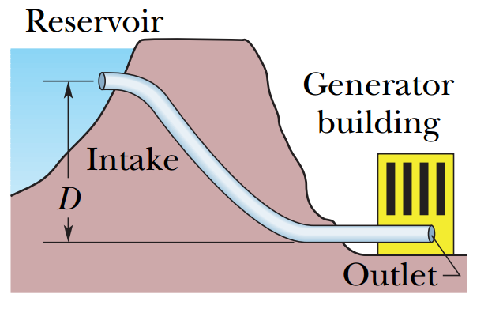
9. The intake in Fig. 14-47 has cross-sectional area of 0.74 m² and water flow at 0.40 m/s. At the outlet, distance D = 180 m below the intake, the cross-sectional area is smaller than at the intake and the water flows out at 9.5 m/s into equipment. What is the pressure difference between inlet and outlet?

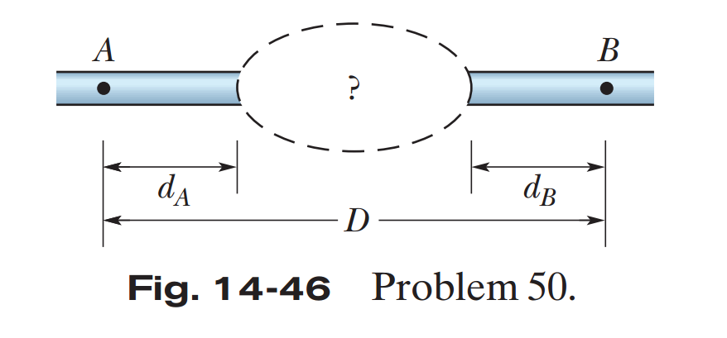
10. Figure 14-46 shows two sections of an old pipe system that runs through a hill, with distances d_{A} = d_{B} = 30 m and D = 110 m. On each side of the hill, the pipe radius is 2.00 cm. However, the radius of the pipe inside the hill is no longer known. To determine it, hydraulic engineers first establish that water flows through the left and right sections at 2.50 m/s. Then they release a dye in the water at point A and find that it takes 88.8 s to reach point B. What is the average radius of the pipe within the hill?

11. Suppose that you release a small ball from rest at a depth of 0.600 m below the surface in a pool of water. If the density of the ball is 0.300 that of water and if the drag force on the ball from the water is negligible, how high above the water surface will the ball shoot as it emerges from the water? (Neglect any transfer of energy to the splashing and waves produced by the emerging ball.)

Answers
- 1.48 × 10³ N; 1.88 × 10⁵ Pa
- 1.07 m²
- (a) 9.80 N (b) 6.17 N
- (a) 7.00 cm (b) 2.80 kg
- (a) 17.7 m/s (b) 1.73 mm
- 31.6 m/s
- 68.0 kPa
- (a) 1.06 m/s (b) 4.24 m/s
- 1.7 MPa
- 3.6 cm
- 1.4 m

